**APPLICATIONS OF NOR AND NAND GATE**

**NOR GATE**

As part of an aircraft’s functional monitoring system, a circuit is required to indicate the status of the landing gears prior to landing. A green LED display turns on if all three gears are properly extended when the “gear down” switch has been activated in preparation for landing. A red LED display turns on if any of the gears fail to extend properly prior to landing. When a landing gear is extended, its sensor produces a LOW voltage. When a landing gear is retracted, its sensor produces a HIGH voltage. Implement a circuit to meet this requirement.

**EXPLAINATION**

Power is applied to the circuit only when the “gear down” switch is activated. Use a NOR gate for each of the two requirements as shown in Figure 3–40. One NOR gate operates as a negative-AND to detect a LOW from each of the three landing gear sensors. When all three of the gate inputs are LOW, the three landing gears are properly extended and the resulting HIGH output from the negative-AND gate turns on the green LED display. The other NOR gate operates as a NOR to detect if one or more of the landing gears remain retracted when the “gear down” switch is activated. When one or more of the landing gears remain retracted, the resulting HIGH from the sensor is detected by the NOR gate, which produces a LOW output to turn on the red LED warning display

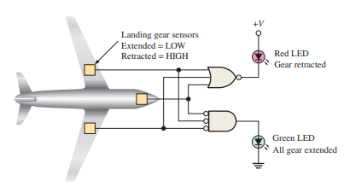

**NAND GATE**

Burglar Alarm

When the switch is closed one input of the NAND gate is LOW. When the LDR is in the light the other input is LOW. This means that if either of these things happen, i.e. the switch is closed or the light is on one of the inputs is LOW, the output is HIGH and the buzzer sounds.

